PROJECT TITLE
Project Title – WEATHER MONITORING SYSTEM

GROUP MEMBERS

Year | Div | Name | Enrollment Number
SYBCA | A | Tirth Shah | GLS0000001
SYBCA | B | Riya Patel | GLS0000002
SYBCA | C | Aman Joshi | GLS0000003

Faculty Signature:

ABSTRACT
This project focuses on developing a weather monitoring system capable of collecting real-time environmental data such as temperature, humidity, and atmospheric pressure using sensors. The data is processed and displayed locally on an LCD and can also be accessed remotely via Wi-Fi. The system uses a microcontroller like Arduino Uno along with sensors like DHT11 and communication modules such as ESP8266. It is designed for applications like agriculture, urban infrastructure, and environmental research where real-time weather monitoring is crucial. The goal is to build an efficient, low-cost, and portable system that helps users track climate changes and environmental conditions easily and accurately.

OBJECTIVE
- The primary objective of this project is to develop a low-cost, portable, and real-time weather monitoring system that continuously tracks environmental factors like temperature and humidity.
- The aim is to provide accurate, live data that can be accessed both locally
and remotely.
- This system will assist farmers, environmentalists, and researchers in monitoring weather conditions that directly impact agriculture, health, and safety. Additionally, the system is intended to be easy to use, energy-efficient, and capable of storing or transmitting historical data for analysis.
- The inclusion of wireless communication ensures real-time alerts and updates, making the system useful for both rural and urban areas.
- By using commonly available components and open-source tools, the
project seeks to deliver a practical solution for small-scale and educational use, promoting hands-on understanding of embedded systems, sensors, and IoT technologies.

COMPONENTS
- Hardware Components:
  - Arduino Uno
  - DHT11 Sensor
  - LCD Display
  - ESP8266 Wi-Fi Module

- Software Components:
  - Arduino IDE
  - Embedded C code

COMPONENTS FUNCTIONALITY

Hardware Components Functionality:
  - DHT11 Sensor: Measures temperature and humidity and sends the data digitally to the Arduino.
  - Arduino Uno: Acts as the brain of the system, reads sensor values, processes the logic, and communicates with output devices.
  - LCD Display: Displays real-time environmental data (e.g., temperature and humidity) on screen.
  - ESP8266 Wi-Fi Module: Sends sensor data to a remote server or dashboard for internet-based monitoring.

Software Components Functionality:
  - Arduino IDE: Provides the environment to write, compile, and upload code to the Arduino board.
  - Embedded C Code: Contains the program logic that reads sensor data, updates the display, and controls data transmission.

WORKING OF SYSTEM
The weather monitoring system begins operation when power is supplied to the Arduino Uno microcontroller. Upon startup, the Arduino initializes all connected components including the DHT11 sensor, LCD display, and the ESP8266 Wi-Fi module. The DHT11 sensor continuously measures environmental parameters such as temperature and humidity. This data is sent to the Arduino, which processes and converts the raw readings into meaningful values. These processed values are displayed on an LCD screen in real-time, allowing local monitoring. Simultaneously, the ESP8266 module is used to transmit the data wirelessly to a cloud platform or web server, enabling users to access the readings remotely from a browser or mobile app. The system updates readings periodically, ensuring users receive current environmental data at all times. It is a low-cost, reliable solution that operates continuously and can be deployed in both indoor and outdoor environments for climate observation and analysis.

FUNCTIONALITY OF SYSTEM
- Real-time temperature and humidity monitoring
- Data display on LCD
- Wireless data transmission via Wi-Fi
- Internet accessibility from any location
- Low-cost and energy-efficient solution
- Easy to build and maintain
- Suitable for smart agriculture and environmental monitoring

Circuit Diagram

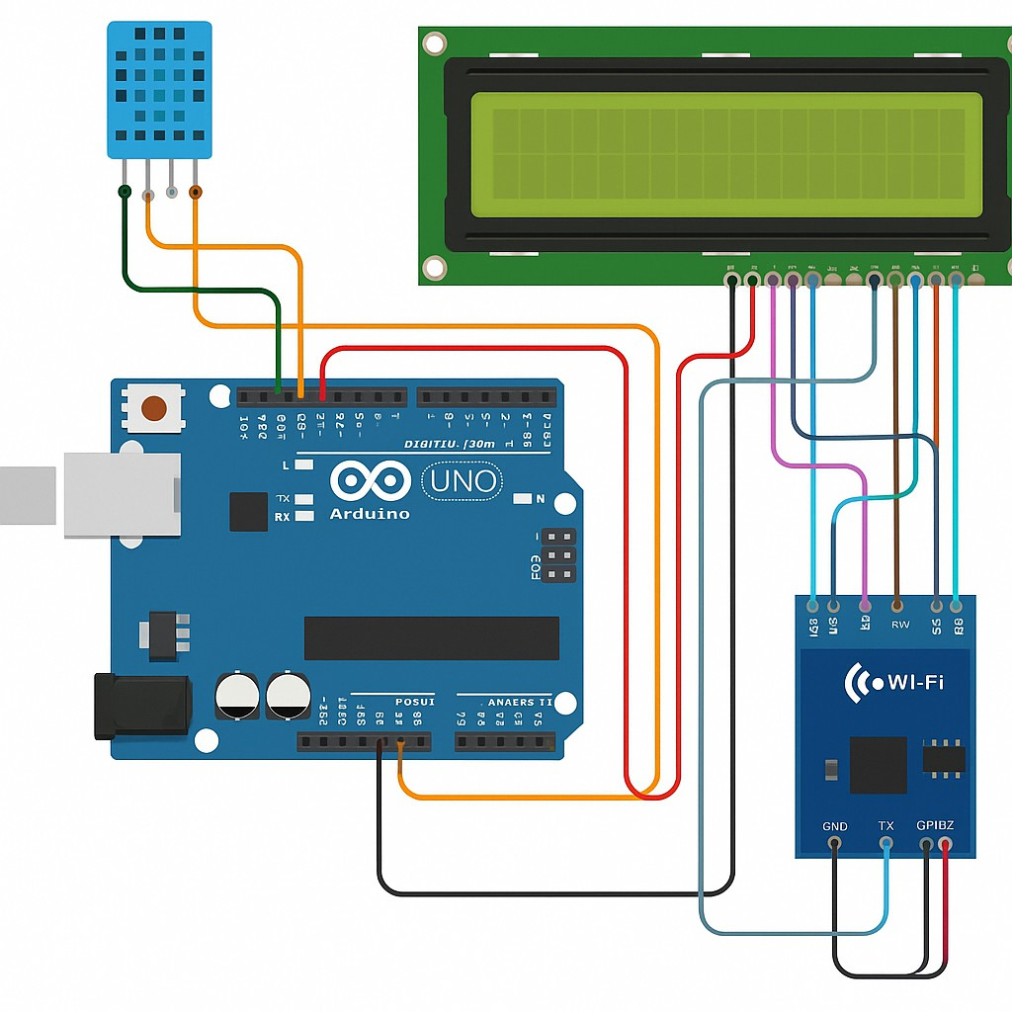

NOTE: SUBMIT HARD COPY OF THE DOCUMENT

Formatting Instructions:
  - Font Size: 14 [Headings] and 12 for Content

  - Font Face: Times New Roman

  - Font Color: Black

  - Headings:

    - Should be in ALL CAPS

    - Bold

Content: Justified, regular (not bold), and properly spaced

